1. **Objectives**
2. Objective Function is to minimize Travel Time
3. Traffic data incorporation within the framework for enhanced Network Analysis
4. Multiple PickUp and Delivery requirements to be satisfied
5. Reduced road capacity to be updated by user depending on the disaster and location
6. Real-time solution capability taking into consideration the variety of constraints like changing capacities, traffic, demand, etc.
7. Hierarchical multi-modal transportation (Road, Water, Air, Rail, etc.) of different heterogeneous capacities and parameters
8. Estimation of different parameters of interest like critical nodes and critical transportation segments
9. Deliver a DSS tool with provision of feeding the live traffic data.
10. **Summary of the work done**
11. Algorithm Development for the Vehicle Routing Problem:
    1. The initial VRP formulation for a simultaneous Delivery and PickUp using Heterogeneous Vehicles has been developed for a single Depot. This formulation itself was optimized so that the overall fastest formulation has been finalised from among 3 (the reduced version of our developed exact formulation is faster than the 2 already available in Literature)
    2. Three Heuristics were developed. The first ATSAHeuristic was a modified version of an HLS Heuristic available in (Avci Topaloglu 2016). We developed newer concepts and introduced a Machine Tuning feature in the Heuristic so that the best solution is now generated more swiftly. This ATSA-MT was further improvised to include the added feature of a JellyFishing search (similar to the movement of the Bell of a JellyFish).
    3. We have done **computational study** on these which may be referred in the attached PDF.
12. QGIS Plugin Development:
    1. The QGIS software is used to develop the DSS.
    2. OpenStreetMaps is being used to obtain the Maps containing the road networks
    3. The user would also be able to disconnect the road segments which cannot be used due to the natural disaster (ex: some roads would be inaccessible during major floods)
    4. This network is being filtered for each vehicle so that we obtain the variant specific network (since very big heavy vehicles shall not be able to enter small by-lanes). Therefore these networks are used to obtain the respective distance matrices which differ among the types of vehicles.
    5. The final route which is being generated is to be visualised on the map in QGIS (this is work in progress)
13. **Activity wise schedule with expected date of completion as per original proposal and actual date of completion**

**AND**

**v) Work proposed to be done during the next year**

|  |  |  |  |
| --- | --- | --- | --- |
|  | **Features** | **Already Incorporated** | **Yet to be Incorporated** |
|
|  |  |  |  |
| **Algorithm** | Heterogeneous Fleet of Vehicles (differ in their Capacities) |  |  |
| Heterogeneous Fleet of Vehicles (differ in their Average Speeds affecting the Layerwise Pre-processing) |  |  |
| Vehicle Compatibility with Road [Different types of Vehicles have different road networks as they may not be able to travel in all road networks] |  |  |
| Simultaneous Delivery and PickUp |  |  |
| Static Traffic Modelling for each Vehicle Type (based on speed inputs for each Vehicle-Type in road-segments) |  |  |
| Allowing Multiple Trips [Replenishment from Depot will become essential in case of huge quantities of relief material required for large number of evacuees] |  |  |
| Enabling Hierarchial Transportation / Crossdocking |  |  |
| Road Capacity Reduction Update [This may be incorporated alongwith traffic, so that a road segment which normally allows all vehicles may now allow only the lightest vehicles or None at all] |  |  |
| Split Delivery and PickUp (user's choice as well as algorithm recommendation of which would be best configuration) |  |  |
| Extending the single Load Type presently considered, into various different Types of Loads individually for the Delivery and the PickUp |  |  |
| Consider Load Type and Vehicle Type compatibility |  |  |
| Consider both Weight and Volume for Delivery and PickUps within the capacity constrained vehicles |  |  |
| Introduction of a Mother Vehicle which would also carry payloads like Floatable-Boats which can inflate and deploy relief material for water stuck victims. These would also be able to take the stranded victims back to the Mother Vehicle) |  |  |
| Bifurcating the existing concept of a Depot (which requires all major functionalities to be present in the same location) into different Functional Elements like VehicleDepots, Warehouses, Nodes, Relief Centres, TranshipmentPoints (for cross docking and intermodal load transfer acting as temporary load holding stations only during the Operation) and HybridDeploymentPorts (these deployment positions would be Nodes for the Mother Vehicles to deploy inflatable boats for urban/rural rescue missions with payloads and accept them at other such Deploy Ports alongwith their rescued people) |  |  |
| Multiple such Functional Depots |  |  |
| Functional Depots with appropriate capacity constraints |  |  |
| Time Minimization (Cascaded and Makespan for minimizing the maximum Time taken for completing the overall Emergency Operation) |  |  |
| Allowing the user to choose the desired Objective Function and required constraints so that the problem itself may change dynamically as per requirement to work in the specific type of emergency |  |  |
|  |  |  |  |
| **Software** | QGIS used for plugin development (altering the QNEAT3 open-source Plugin) |  |  |
| Obtaining open-source map with appropriate transportation network from OSM |  |  |
| Removing links from existing network and Filtering it (indicating unavailable roads due to the disaster) |  |  |
| Bifurcating the Network into individual Vehicle Type specific networks (Vehicle Road compatibility) |  |  |
| Visualization of the solution within the QGIS map |  |  |
| Obtaining individual work specifications for each Vehicle so that each Crew can be provided their tasks |  |  |

Our present assumptions include:-

1. Relief supply materials are not differentiated [based on say Food, Water, Medicine, Sanitary Items]. Vehicles presently deliver “Quantities” which may be internally a combination of all these
2. 1 Quantity of Demand takes same space and has same weight as 1 unit of Pick-Up, i.e. they have the same density.
3. Cost Minimization is to be extended to time minimization.

Ultimately, the operator would be able to decide which type of problem to choose as per the requirements. The rough idea of our next steps involve allowing the development of the Time Minimization problem under the Simultaneous Delivery and Pickup case and continue development of the other clusters in the below segmentation.

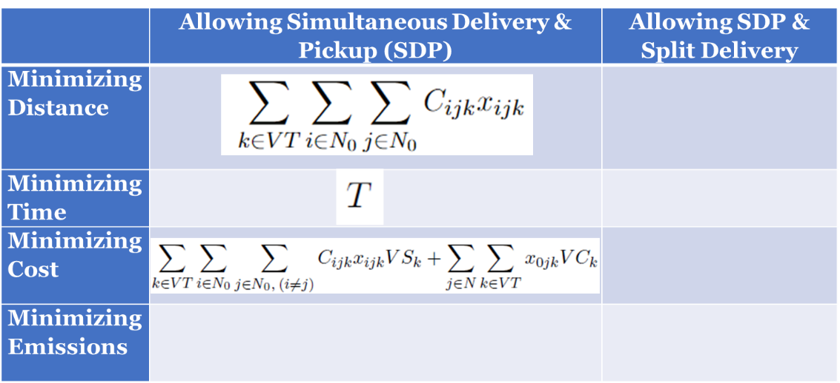

Details regarding this part of the Algorithm development as well as the final software (whether the deliverable would be a plugin or a separate Web Application) is to be further discussed with the client.